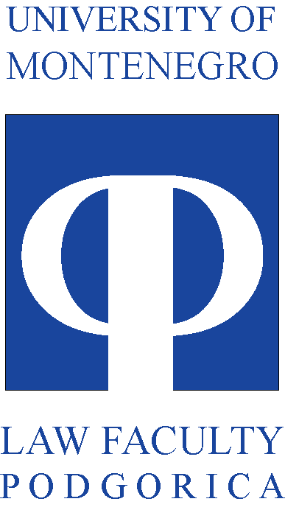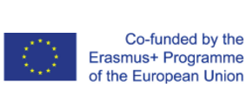

___________________________________________________________________________

STUDENTS INVOLVEMENT IN THE CABUFAL PROJECT
Report for 2017

Since the Management board is focused on projects progress in terms of expenditure, use of resources, implementation of activities and the delivery of results, in order to assure achievement of the defined goals of the project, one of its functions is to systematically collect and analyze relevant information about project progress. In that regard, management team is submitting this report.
During the first year of the project, Project coordinator, with the assistance of project management team, in regard of involvement of Faculty of law University of Montenegro students were focused on raising their awareness of the project aims and their involvement in the realization of the project activities. In that regard, they have been involved since the day one of the CABUFAL existence, and have been represented at the kick off CABUFAL meeting, in Budva in March of 2017.
By the project description it was stated that the students will be the part of the management structure of the project and that some of the activities will be focused on them specifically.
In that regard during May, June and July of 2017 prospective student were informed on the existence of the CABUFAL project and its aims during the enrolment of the new generation of students. Every student has received the short pamphlet in Montenegrin language on CABUFAL project and its identity (logo of the project) with short information on project international and domestic partners in this project. The following pictures represent the pamphlet that was presented to all student during the enrolment procedures in 2017.

Also it should be noted that the student representatives, during the first year of the project, were included in all relevant project activities. One student representative is the member of the Quality assurance board, and is privy to reports on all realized activities and the workings of this board and its assessments of the realization of the project activities.
In that regard, it should be also mentioned that students of the Faculty of Law University of Montenegro had three representatives present at the first training session organized in Podgorica in September of 2017.

