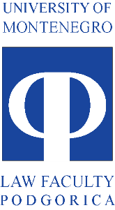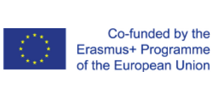

__________________________________________________________________________________

ANNUAL REPORT ON
LANGUAGE COURSES

Since the Management board is focused on projects progress in terms of expenditure, use of resources, implementation of activities and the delivery of results, in order to assure achievement of the defined goals of the project, one of its functions is to systematically collect and analyze relevant information about project progress. In that regard, Project management team is submitting this Annual report on language courses organized in the first year of the project.
By description of this project activity it was foreseen that the Language courses will be organised for all members of the academic staff of the Faculty of law University of Montenegro, and that depending on the interest of the academic staff language courses could be organised either on the beginner level for the teachers that want to learn new language or on the advanced level for the teachers that want to advance their previous foreign language knowledge to academic level. Language training was to be subcontracted.
After the completion of the public procurement procedure for the language training services, International House Cambridge Centar Podgorica was selected as the contractor that will provide the language training within the project. IH Center is the licensed language school that is organizing their courses in accordance with the Common European Framework of Reference for Languages. Public procurement procedure was finished during the September of 2017.
Soon after, the first trainings have started. Two professors and two teaching assistants have attended the trainings until the end of December 2017.
One professor was attending the classes in English language on C1 level and is awaiting examinations in February of 2018.
One professor was attending the classes in German language on A2 level and has successfully completed the course in December of 2017.
Two teaching assistants were attending the classes in German language on A1/1 level and have successfully completed the course in December of 2017.
Other professors have stated their interest for French as their option for language trainings, and are awaiting the formation of the group that will start their first classes in February of 2018.
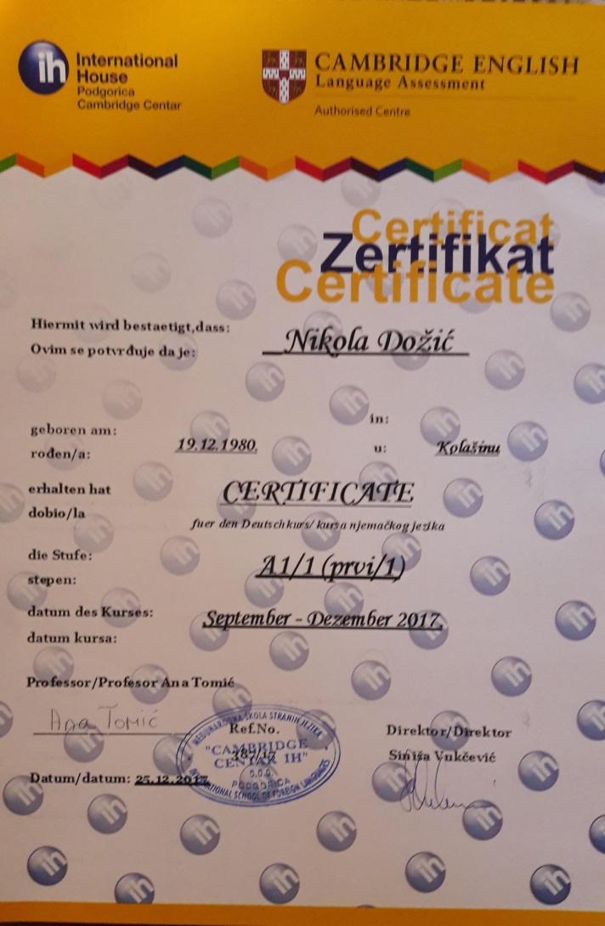  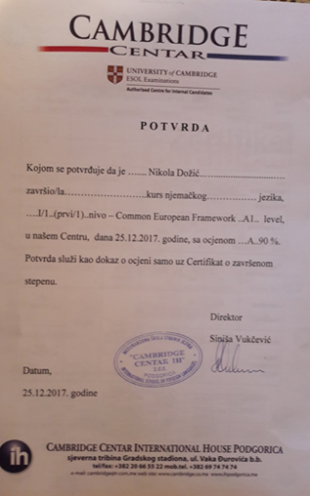 | 