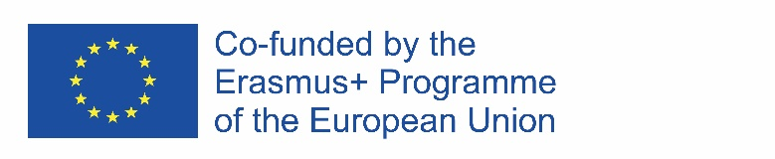

Report on the Literature procurement for 2017

The Management board has the competence over thee on CABUFAL progress in terms of expenditure, use of resources, implementation of activities and the delivery of results, in order to assure achievement of the defined goals of the project, one of its functions is to systematically collect and analyze relevant information about project progress. In that regard, management team is submitting this report.
During the first year of the project, Project coordinator, with the assistance of project management team, has completed the literature procurement for Faculty of law University of Montenegro.
In accordance with the Amendments to Financial plan of the University of Montenegro for 2017, national procedure rules stipulated by the Law on procurement and Law on higher education, public procurement procedure has been handled for the 2017.
All procurements, including Literature procurement, have been published with other procurements the entire University of Montenegro procurement calls, but as a separate point of the procurement. The procedure was successfully realized, so that 328 bibliographic titles on english, french and german covering all legal disciplines have been procured.
Full documentation of the procurement is available at:http://portal.ujn.gov.me/delta2015/search/displayNotice.html?id=113106&type=InvitationPublicProcure___

