ANNEX 4 - QUESTIONNAIRES analysis.

Evaluation of the Kick off meeting Budva
- Please tick: 4 = Best rating, 1 = Worst rating 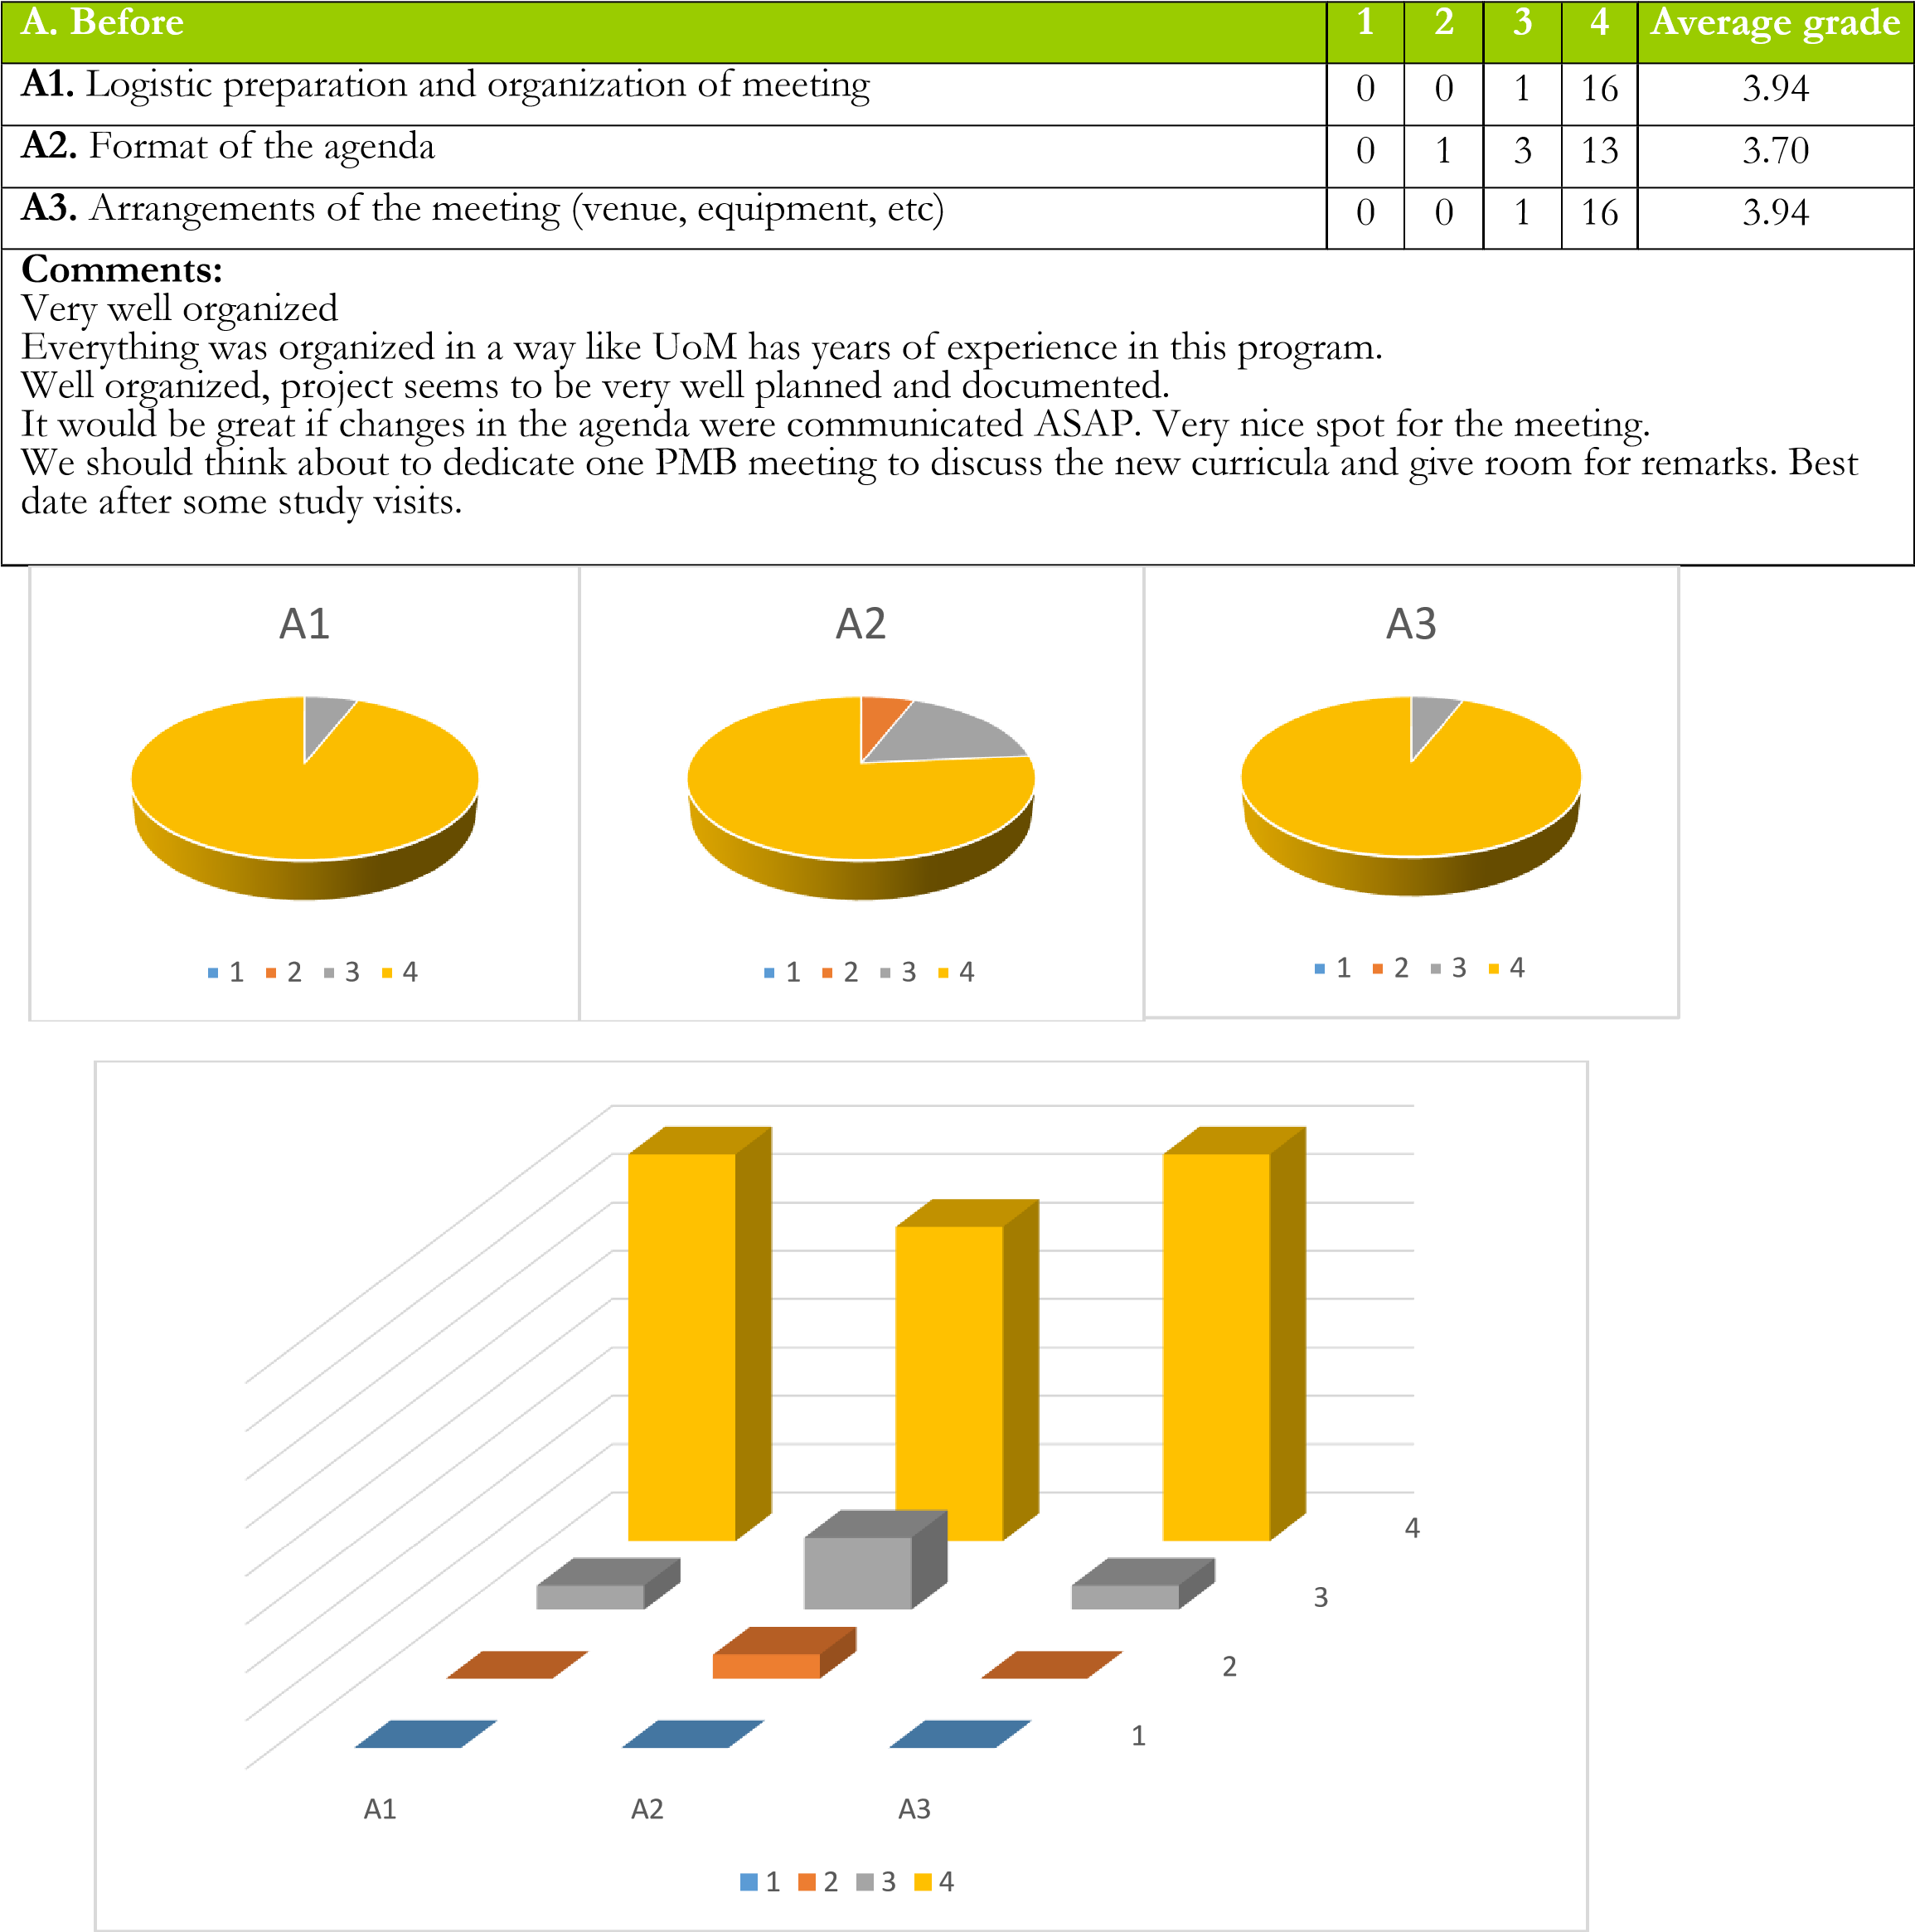
- Please tick: 4 = Best rating, 1 = Worst rating

B. During | 1 | 2 | 3 | 4 | Average grade
B1. Communication between the coordinator of the project and the | 0 | 0 | 2 | 14 | 3.85
B2. Quality of presentations and other materials provided during the meeting | 0 | 0 | 2 | 14 | 3.85
B3. Clearness of the presentations of the presentations | 0 | 0 | 5 | 11 | 3.68
B4. Objectives in the agenda regarding the CABUFAL project reached | 0 | 0 | 2 | 14 | 3.85
B5. Usefulness of the tasks within the project | 0 | 0 | 2 | 13 | 3.86
B6. Duration and timetable of the meeting | 0 | 2 | 4 | 11 | 3.52
B7. Enrolment of the participants in the activities and discussions | 0 | 0 | 4 | 12 | 3.75
Comments:
It is still not clear what are the expectation and scheme of some tasks.
Nameplates or introduction round would be helpful.
The whole program was designed and executed so partner institutions have clear ideas how to contribute and benefit from the project.

B1  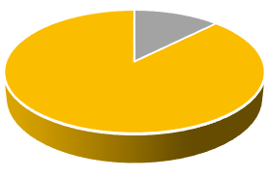  1  2  3  4 |  | B2  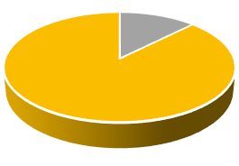  1  2  3  4 |  | B3  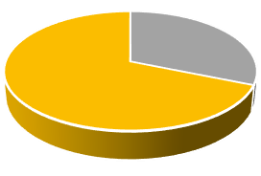  1  2  3  4 |  | B4  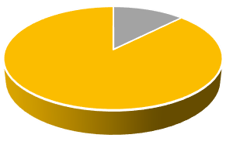  1  2  3  4
 | B5  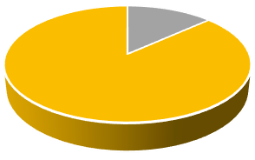  1  2  3  4 |  | B6  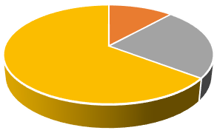  1  2  3  4 |  | B7  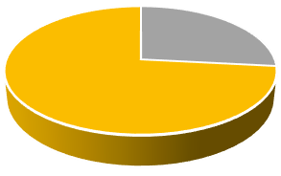  1  2  3  4
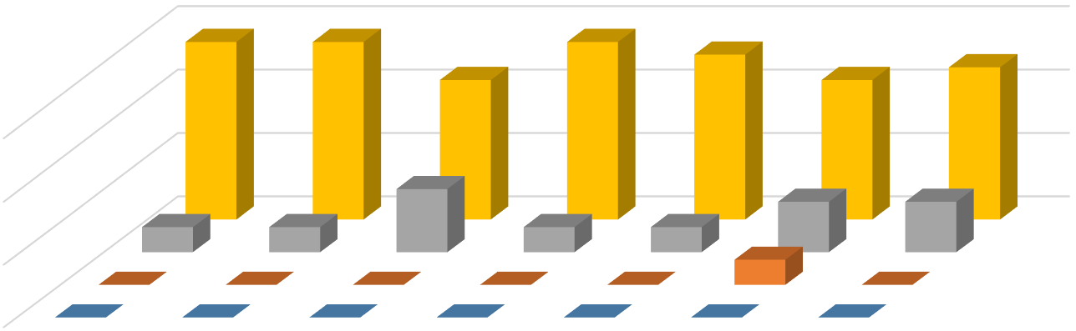

1
2
3
4
B1
B2
B3
B4
B5
B6
B7
1
2
3
4

- Please tick: 4 = Best rating, 1 = Worst rating

C. After | 1 | 2 | 3 | 4 | Average grade
C1. Mode of decisions made in the meeting | 0 | 1 | 1 | 14 | 3.81
C2. Opportunities to express your opinion and influence decisions | 0 | 0 | 0 | 16 | 4.00
C3. Achievement of the meeting and project goals | 0 | 0 | 3 | 12 | 3.80
C4. Discussion of manner tasks for next activities and meetings | 0 | 1 | 1 | 14 | 3.81
Comments:
I would improve the project to have a clear roadmap for the upcoming years and definition of years.
Thanks for the great assistance and showing us Montenegro.
It would be good to be given a clear idea of what is expected of the participants how we can be useful. Discussions were lively and have led to decisions that were unanimously agreed. Thank you for your kind hospitality!

C1 1 2 3 4 C2 1 2 3 4 C3 1 2 3 4 | 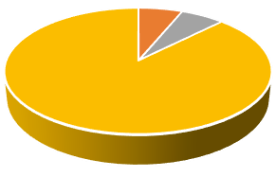  C4  1  2  3  4

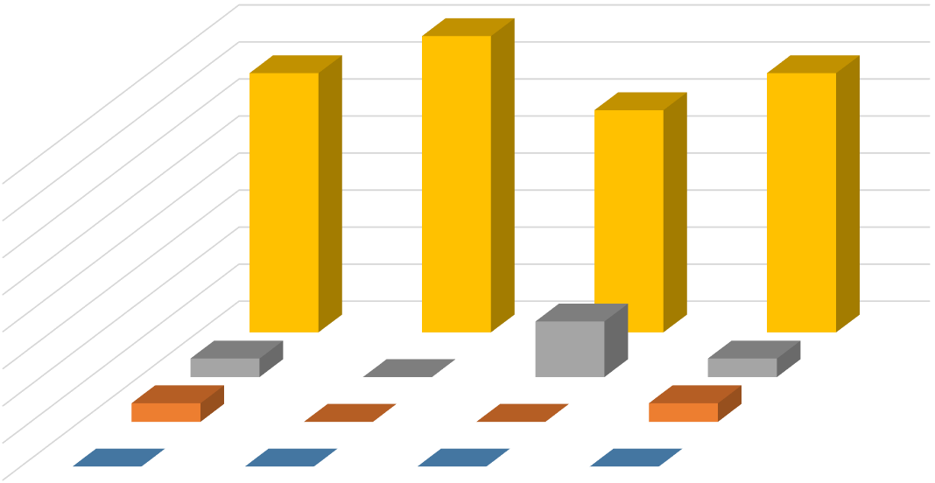

1
2
3
4
C1
C2
C3
C4
1
2
3
4

Summary report on questionnaire responses

- Center for training in the judiciary and the state prosecutor's office (hereinafter: the Center), as one of the partners in the project "Capacity building of the faculty of law" (CABUFAL), conducted a study on how much Montenegrin judges, state prosecutors and attorneys are familiar with EU law and how much it is present in their work at the moment.

- Therefore, the Center for the training in the judiciary and the state prosecutor's office prepared the questionnaire for the judges, state prosecutors and attorneys which Judicial Council passed to all Montenegrin courts, to all state prosecutors and through Bar Associations to all attorneys in Montenegro.

- The questionnaire was filled and returned by 110 judges (out of 317), 56 sate prosecutors (out of 119) and 6 attorneys.

- Analysis of the submitted responses to the first question, how judges assess their knowledge in the field of EU law, shows that the 33 judges assessed as unsatisfactory (one attorney, 10 state prosecutors), 52 judges as satisfactory (3 attorneys, 25 state prosecutors), 20 judges as well (2 attorneys, 19 state prosecutors), four judge as very good (one state prosecutor), while only one judges assessed as excellent (one state prosecutor).

- Furthermore, regarding question number two, the judges agree in the opinion that continuous training is required in this area, where 12 stated that the training should be carried out once a year, 21 that the training should be implemented twice a year (one attorney), while 17 considers that the training should be conducted three times a year. The majority of judges, 60 of them, believe that the training is necessary to be carried out 4 or more times a year (attorneys and state prosecutors share the same opinion).

- Attorneys said that the training should be implemented as often as possible, at all levels, starting with local government bodies, employees of courts and public prosecutor's offices, lawyers, and representatives of the state administration. Thay propose that traning should be conducted from the initial to the expert level.

- As for the question number 3, which refers to the number of training that judges attended in the field of EU law, organized by the Center for the training of the judiciary and the public prosecutors, 53 judges said they did not attend any training (15 state prosecutors), 17 judges and 14 state prosecutors that have attended one training, while 40 judges and 9 state prosecutors stated that thay been in training organized by the Center more than once (on several occasions). As a reason for not attending training, 4 judges stated that they could not because workload, ten judges said they were not invited (all attorneys said that thay was not invited), while rest of the respondents did not give the answer (same thing is with state prosecutors).

- Regarding question number 4, on the number of training that judges attended in the field of EU law, and that is not organized by the Training Center, 55 judges stated that thay not attended such training, 15 of them was able to attend such training (8 state prosecutors once, 1 twice, 4 several times) while 40 judges could not declare - they did not give an answer (same thing is with state prosecutors).

- One attorney said that he attend such training at the University, while the two lawyers declared that they had the opportunity to attend this kind of training (organized by OSCE - Organization for Security and Co-operation in Europe, CEDEM and the Helsinki Committee).

- From all submitted responses, it appears that the judges agree in opinion in relation to question number 5 and believe that the training carried out by the Training Center contributes to improving (significantly) their knowledge in the field of EU law.

- Question number 6 - Satisfaction with training events organized by the Center, the judges who attended training (grades gave 75 judges), assessed as follows:

- Topicality: 1 one judge, 2 two judges (1 state prosecutor), 3 – 14 judges (6 state prosecutors), 4 – 18 judges (24 state prosecutors), 5- 40 judges (22 state prosecutors)
- Diversity of topics: 1 one judge, 2 two judges (3 state prosecutors), 3 – 17 judges (3 state prosecutors), 4 -27 judges (26 state prosecutors), 5 – 28 judges (21 state prosecutors)
- Methodology of work: 1 -0, 2 - 8 judges (1 state prosecutors), 3 -13 judges (8 state prosecutors), 4 – 18 judges (32 state prosecutors), 5 – 36 judges (12 state prosecutors)
- Quality of lectures: 1 one judge, 2- 4 judges (1 state prosecutor), 3 – 5 judges (8 state prosecutors), 4 – 23 judges (19 state prosecutors), 5 – 42 judges (25 state prosecutors)
- Organization of traning: 1 one judge, 2 one judge (1. state prosecutor), 3 – 8 judges (5 state prosecutors), 4- 21 judges (19 state prosecutors), 5 – 44 judges (28 state prosecutors)

- From all submitted responses to questions 5 and 6, which are related to the assessment of satisfaction with quality of training conducted by the Center, it appears that the attorneys were not able to declare, considering that thay did not attend the training that the Center organized.

- Question number 7 - Regarding topics in the field of EU law, for which they are particularly interested, the judges said: criminal law (detention, international legal mutual assistance in criminal matters), freedom of expression and its limits, prohibition of discrimination and mobbing, prohibition of torture and inhuman or degrading treatment or punishment, the right to trial within a reasonable time, violation of personality rights and compensation for damages in civil proceedings.

- Attorneys are particularly interested in: fild of cross-border trade, labor law, intellectual property, environmental protection, copyright and bankruptcy law, criminal law in the area of international cooperation and enforcement of judicial decisions, practise of the Court of Justice of the EU, peaceful settlement of disputes.

- State prosecutors stated that thay are especially interested in criminal law and practice of the Court of Justice of the EU and the European Court of Human Rights (Article 5, 6 and 7 of the ECHR (right to liberty and security, right to a fair trial, no punishment without law), criminal law and criminal procedure law of EU, human rights, copyright rights, rights of a child, the confidentiality of information, police and judicial cooperation in the EU, pre-trial detention, plea bargain, the prohibition of torture and the prohibition of discrimination, the Court of Justice of the EU (decisions, jurisdiction and procedure), the right to citizenship in the EU, freedom and security.

- Question number 8 - As for the suggestions and recommendations relating to the organization of future activities on the subject topic, analysis of the submitted questionnaires shows that most of the suggestions refers to the need for more frequent training, which will involve all judges in Montenegro. This refers to all respondents.

- They find that training should last longer and enable more interaction among the participants, as well as the exchange of experiences. Teachers should be judges or a persons with experience in the field of international law and practice of the European Court of Human Rights. Most of the submitted responses emphasizes the need to delivery of relevant literature to judges, with the translated judgments of the European Court of Human Rights and practical examples from case law. The literature should be available to the judges who attended the training, and to all other judges of a particular court.

- Attorneys and state prosecutors agree in opinion that the teachers in this area should be practitioners who deal with EU law (lawyers, judges and prosecutors) as well as experts in political and legal theory (university professors). In terms of trainings agreed that the training should be implemented in cycles, lasting 1-3 days, not more than five hours a day. When it comes to methodology thay proposed processing as many practical examples, exchange of experiences through discussion, distribute appropriate literature and visits to EU institutions. One attorney pointed out that it would be useful experience of Croatia and Slovenia.

Evaluation of study visit to Faculty of Law University of Ljubljana

Question |  | Grade |  |  |  |  |  | Evaluation method | Average grade
 |  | 1 |  | 2 | 3 | 4 | 5
Q1. | Your objectives for participating in the study visit were: | 0 |  | 0 | 0 | 0 | 3 | 1. - not met;  5. - extremely well met. | 5.00
Q2. | The relevancy of places visited in relation to study visit objectives was: | 0 |  | 0 | 0 | 0 | 3 | 1. - not relevant;  5. - highly relevant. | 5.00
Q3. | To what extent do you find study visit topics relevant to topics you are interested in? | 0 |  | 0 | 0 | 1 | 2 | 1. - not relevant;  5. - highly relevant. | 4.66
Q4. | Were you satisfied with your participation in study tour? | 0 |  | 0 | 0 | 0 | 3 | 1. - fully unsatisfied;  5. - fully satisfied. | 5.00
Q5. | How do you rate the logistics and accommodation of the program? | 0 |  | 0 | 0 | 0 | 3 | 1. - poor;  5. - excellent. | 5.00
Q6. | How familiar were you with the topics covered during the lectures during this study visit? | 0 |  | 0 | 1 | 1 | 1 | 1. - all new;  5. - very familiar. | 4.00
Q7. | Do you consider it useful to continue transferring experience, skills, knowledge. teaching methods within CABUFAL partner countries? | 3 |  | 0 | 0 | 0 | 0 | 1.-yes;  2.-no. | 100%
Q8. | Exposure to respective individual syllabuses and teaching methodologies during study visit will trigger the changes on your course? | 3 |  | 0 | 0 | 0 | 0 | 1.-yes;  2.-no. | 100%
Q9. | What are the issues to be subject of the future cooperation between your Faculty of Law UoM, and Faculty of Law, University of Ljubljana? |  | - Exchange of professors and students
Q10. | Any additional comments for the question 1-8 or otherwise: |  | - Excellent

Evaluation of study visit to Europa Institute - Saarland University

Question |  | Grade |  |  |  |  |  | Evaluation method | Average grade
 |  | 1 |  | 2 | 3 | 4 | 5
Q1. | Your objectives for participating in the study visit were: | 0 |  | 0 | 0 | 2 | 7 | 1. - not met;  5. - extremely well met. | 4.77
Q2. | The relevancy of places visited in relation to study visit objectives was: | 0 |  | 0 | 0 | 1 | 8 | 1. - not relevant;  5. - highly relevant. | 4.89
Q3. | To what extent do you find study visit topics relevant to topics you are interested in? | 0 |  | 0 | 1 | 2 | 6 | 1. - not relevant;  5. - highly relevant. | 4.56
Q4. | Were you satisfied with your participation in study tour? | 0 |  | 0 | 0 | 0 | 9 | 1. - fully unsatisfied;  5. - fully satisfied. | 5.00
Q5. | How do you rate the logistics and accommodation of the program? | 0 |  | 0 | 0 | 0 | 9 | 1. - poor;  5. - excellent. | 5.00
Q6. | How familiar were you with the topics covered during the lectures during this study visit? | 0 |  | 1 | 1 | 2 | 5 | 1. - all new;  5. - very familiar. | 4.22
Q7. | Do you consider it useful to continue transferring experience, skills, knowledge. teaching methods within CABUFAL partner countries? | 9 |  | 0 | 0 | 0 | 0 | 1.-yes;  2.-no. | 100%
Q8. | Exposure to respective individual syllabuses and teaching methodologies during study visit will trigger the changes on your course? | 9 |  | 0 | 0 | 0 | 0 | 1.-yes;  2.-no. | 100%
Q9. | What are the issues to be subject of the future cooperation between your Faculty of Law UoM, and Europa Institute – Saarland University? |  | - Teacher and student mobility  - Staff mobility  - Joint master studies  - International judicial cooperation  - Private law issues  - Enviormental law issues
Q10. | Any additional comments for the question 1-8 or otherwise: |  | - Excellent overall  - Best organized study visit in my experience (so far)

Evaluation of study visit to Regents University in London

Question |  |  | Grade |  |  |  |  | Evaluation method | Average grade
 |  |  | 1 | 2 | 3 | 4 | 5
Q1. | Your objectives for participating in the study visit were: |  | 0 | 0 | 0 | 1 | 12 | 1. - not met;  5. - extremely well met. | 4.92
 |  |  | 0 |  | 0 | 1 | 12 |  | 4
Q2. | The relevancy of places visited in relation to study visit objectives was: |  | 0 | 0 | 0 | 1 | 12 | 1. - not relevant;  5. - highly relevant. | 4.92
Q3. | To what extent do you find study visit topics relevant to topics you are interested in? |  | 0 | 0 | 0 | 1 | 12 | 1. - not relevant;  5. - highly relevant. | 4.92
Q4. | Were you satisfied with your participation in study tour? |  | 0 | 0 | 0 | 1 | 12 | 1. - fully unsatisfied;  5. - fully satisfied. | 4.91
Q5. | How do you rate the logistics and accommodation of the program? |  | 5 | 2 | 0 | 1 | 5 | 1. - poor;  5. - excellent. | 3.17
Q6. | How familiar were you with the topics covered during the lectures during this study visit? |  | 0 | 0 | 0 | 2 | 11 | 1. - all new;  5. - very familiar. | 4.85
Q7. | Do you consider it useful to continue transferring experience, skills, knowledge. teaching methods within CABUFAL partner countries? |  | 12 | 1 | - | - | - | 1.-yes;  2.-no. | 92.31%  7.69%
Q8. | Exposure to respective individual syllabuses and teaching methodologies during study visit will trigger the changes on your course? |  | 13 | 0 | - | - | - | 1.-yes;  2.-no. | 100%  0%
Q9. | What are the issues to be subject of the future cooperation between your Faculty of Law UoM, and Faculty of Law, University of Split?
Q10. | Any additional comments for the question 1-8 or otherwise:

Evaluation of study visit to Faculty of Law University of Split

Question |  |  | Grade |  |  |  |  | Evaluation method | Average grade
 |  |  | 1 | 2 | 3 | 4 | 5
Q1. | Your objectives for participating in the study visit were: |  | 0 | 0 | 0 | 0 | 6 | 1. - not met;  5. - extremely well met. | 5.00
Q2. | The relevancy of places visited in relation to study visit objectives was: |  | 0 | 0 | 0 | 1 | 5 | 1. - not relevant;  5. - highly relevant. | 4.83
Q3. | To what extent do you find study visit topics relevant to topics you are interested in? |  | 0 | 0 | 1 | 2 | 3 | 1. - not relevant;  5. - highly relevant. | 4.33
Q4. | Were you satisfied with your participation in study tour? |  | 0 | 0 | 0 | 3 | 3 | 1. - fully unsatisfied;  5. - fully satisfied. | 4.50
Q5. | How do you rate the logistics and accommodation of the program? |  | 0 | 0 | 0 | 0 | 6 | 1. - poor;  5. - excellent. | 5.00
Q6. | How familiar were you with the topics covered during the lectures during this study visit? |  | 0 | 0 | 1 | 1 | 4 | 1. - all new;  5. - very familiar. | 4.50
Q7. | Do you consider it useful to continue transferring experience, skills, knowledge. teaching methods within CABUFAL partner countries? |  | 6 | 0 | 0 | 0 | 0 | 1.-yes;  2.-no. | 100%
Q8. | Exposure to respective individual syllabuses and teaching methodologies during study visit will trigger the changes on your course? |  | 3 | 3 | 0 | 0 | 0 | 1.-yes;  2.-no. | 50% | 50%
Q9. | What are the issues to be subject of the future cooperation between your Faculty of Law UoM, and Faculty of Law, University of Split? | - Joint research in harmonization of EU law  - Joint publishing  - Joint research in harmonization of EU law  - Joint publishing and research  - It could be organized that professors of both Faculties in cooperation with Judicial academies hold some lectures to young judges.
Q10. | Any additional comments for the question 1-8 or otherwise: | - No

Evaluation of the training conducted by Mireille Hebing from Regent University on the topics Higher Education Academy and Methodology in Teaching
Question |  |  | Grade |  |  |  |  | Evaluation method | Average grade
 |  |  | 1 | 2 | 3 | 4 | 5
Q1. | Your objectives for participating in this training were: |  | 0 | 0 | 0 | 1 | 10 | 1. - not met;  5. - extremely well met. | 4.91
Q2. | The relevancy of topics covered by training: |  | 0 | 0 | 1 | 3 | 7 | 1. - not relevant;  5. - highly relevant. | 4.55
Q3. | To what extent do you find training topics relevant to issues you are interested in? |  | 0 | 0 | 2 | 0 | 9 | 1. - not relevant;  5. - highly relevant. | 4.55
Q4. | Were you satisfied with your participation in the training? |  | 0 | 0 | 0 | 1 | 10 | 1. - fully unsatisfied;  5. - fully satisfied. | 4.91
Q5. | How do you rate the logistics of the training? |  | 0 | 0 | 0 | 0 | 10 | 1. - poor;  5. - excellent. | 5.00
Q6. | How familiar were you with the topics prior to participation in this training? |  | 0 | 0 | 2 | 4 | 4 | 1. - all new;  5. - very familiar. | 3.82
Q7. | Do you consider it useful to continue transferring experience, skills, knowledge. and teaching methods within CABUFAL partner countries via trainings? |  | 11 | 0 | 0 | 0 | 0 | 1.-yes;  2.-no. | 100%
Q8. | Exposure to this training will trigger the changes on your course? |  | 11 | 0 | 0 | 0 | 0 | 1.-yes;  2.-no. | 100%
Q9. | What are the topics to be subject of the future trainings? | - More subject oriented  - Syllabus creation that is oriented to individual EU courses  - Harmonization of EU consumer law  - Criminal law
Q10. | Any additional comments for the question 1-8 or otherwise: | - Great project

Evaluation of the training conducted by ass.iur. Mareike Frohlich from Europa Institut University of Saarland
Question |  |  | Grade |  |  |  |  | Evaluation method | Average grade
 |  |  | 1 | 2 | 3 | 4 | 5
Q1. | Your objectives for participating in this training were: |  | 0 | 0 | 0 | 9 | 3 | 1. - not met;  5. - extremely well met. | 4.25
Q2. | The relevancy of topics covered by training: |  | 0 | 0 | 0 | 2 | 10 | 1. - not relevant;  5. - highly relevant. | 4.83
Q3. | To what extent do you find training topics relevant to issues you are interested in? |  | 0 | 0 | 0 | 3 | 9 | 1. - not relevant;  5. - highly relevant. | 4.75
Q4. | Were you satisfied with your participation in the training? |  | 0 | 0 | 0 | 1 | 11 | 1. - fully unsatisfied;  5. - fully satisfied. | 4.92
Q5. | How do you rate the logistics of the training? |  | 0 | 0 | 0 | 3 | 9 | 1. - poor;  5. - excellent. | 4.75
Q6. | How familiar were you with the topics prior to participation in this training? |  | 0 | 0 | 0 | 2 | 9 | 1. - all new;  5. - very familiar. | 4.42
Q7. | Do you consider it useful to continue transferring experience, skills, knowledge. and teaching methods within CABUFAL partner countries via trainings? |  | 11 | 1 | - | - | - | 1.-yes;  2.-no. | 91.67%  8.33%
Q8. | Exposure to this training will trigger the changes on your course? |  | 10 | 2 | - | - | - | 1.-yes;  2.-no. | 83.33%  16.67%
Q9. | What are the topics to be subject of the future trainings? | - No comments
Q10. | Any additional comments for the question 1-8 or otherwise: | - No comments

Evaluation of the training conducted by prof. dr Tomas Giegerich from Europa Institut University of Saarland
Question |  |  | Grade |  |  |  |  | Evaluation method | Average grade
 |  |  | 1 | 2 | 3 | 4 | 5
Q1. | Your objectives for participating in this training were: |  | 0 | 0 | 0 | 6 | 6 | 1. - not met;  5. - extremely well met. | 4.50
Q2. | The relevancy of topics covered by training: |  | 0 | 0 | 0 | 4 | 8 | 1. - not relevant;  5. - highly relevant. | 4.67
Q3. | To what extent do you find training topics relevant to issues you are interested in? |  | 0 | 0 | 0 | 1 | 11 | 1. - not relevant;  5. - highly relevant. | 4.92
Q4. | Were you satisfied with your participation in the training? |  | 0 | 0 | 0 | 2 | 10 | 1. - fully unsatisfied;  5. - fully satisfied. | 4.83
Q5. | How do you rate the logistics of the training? |  | 0 | 0 | 0 | 1 | 11 | 1. - poor;  5. - excellent. | 4.92
Q6. | How familiar were you with the topics prior to participation in this training? |  | 0 | 0 | 0 | 3 | 9 | 1. - all new;  5. - very familiar. | 4.75
Q7. | Do you consider it useful to continue transferring experience, skills, knowledge. and teaching methods within CABUFAL partner countries via trainings? |  | 9 | 3 | - | - | - | 1.-yes;  2.-no. | 75.00%  25.00%
Q8. | Exposure to this training will trigger the changes on your course? |  | 8 | 4 | - | - | - | 1.-yes;  2.-no. | 66.67%  33.33%
Q9. | What are the topics to be subject of the future trainings? | - No comments
Q10. | Any additional comments for the question 1-8 or otherwise: | - No comments

Evaluation of the training conducted by prof. dr Jadranka Dabović Anastasovska from Faculty of law University in Skoplje
Question |  |  | Grade |  |  |  |  | Evaluation method | Average grade
 |  |  | 1 | 2 | 3 | 4 | 5
Q1. | Your objectives for participating in this training were: |  | 0 | 0 | 0 | 2 | 14 | 1. - not met;  5. - extremely well met. | 4,88
Q2. | The relevancy of topics covered by training: |  | 0 | 0 | 0 | 1 | 15 | 1. - not relevant;  5. - highly relevant. | 4,94
Q3. | To what extent do you find training topics relevant to issues you are interested in? |  | 0 | 0 | 0 | 3 | 12 | 1. - not relevant;  5. - highly relevant. | 4,8
Q4. | Were you satisfied with your participation in the training? |  | 0 | 0 | 1 | 5 | 11 | 1. - fully unsatisfied;  5. - fully satisfied. | 4,29
Q5. | How do you rate the logistics of the training? |  | 0 | 0 | 0 | 2 | 14 | 1. - poor;  5. - excellent. | 4,88
Q6. | How familiar were you with the topics prior to participation in this training? |  | 1 | 2 | 3 | 3 | 7 | 1. - all new;  5. - very familiar. | 3,81
Q7. | Do you consider it useful to continue transferring experience, skills, knowledge. and teaching methods within CABUFAL partner countries via trainings? |  | 14 | 2 | - | - | - | 1.-yes;  2.-no. | 87,5%  12,5%
Q8. | Exposure to this training will trigger the changes on your course? |  | 14 | 2 | - | - | - | 1.-yes;  2.-no. | 87,5%  12,5%
Q9. | What are the topics to be subject of the future trainings? | - Intelectual property law  - EU law
Q10. | Any additional comments for the question 1-8 or otherwise: | - No comments

Evaluation of the training conducted by prof. dr Katarina Ristova Aasterud from Faculty of law University in Skoplje
Question |  |  | Grade |  |  |  |  | Evaluation method | Average grade
 |  |  | 1 | 2 | 3 | 4 | 5
Q1. | Your objectives for participating in this training were: |  | 0 | 0 | 1 | 4 | 9 | 1. - not met;  5. - extremely well met. | 4,57
Q2. | The relevancy of topics covered by training: |  | 0 | 0 | 0 | 3 | 10 | 1. - not relevant;  5. - highly relevant. | 4,77
Q3. | To what extent do you find training topics relevant to issues you are interested in? |  | 0 | 0 | 1 | 6 | 8 | 1. - not relevant;  5. - highly relevant. | 4,47
Q4. | Were you satisfied with your participation in the training? |  | 0 | 0 | 2 | 4 | 7 | 1. - fully unsatisfied;  5. - fully satisfied. | 4,38
Q5. | How do you rate the logistics of the training? |  | 0 | 0 | 0 | 5 | 9 | 1. - poor;  5. - excellent. | 4,64
Q6. | How familiar were you with the topics prior to participation in this training? |  | 0 | 0 | 1 | 4 | 9 | 1. - all new;  5. - very familiar. | 4,57
Q7. | Do you consider it useful to continue transferring experience, skills, knowledge. and teaching methods within CABUFAL partner countries via trainings? |  | 13 | 1 | - | - | - | 1.-yes;  2.-no. | 92,86  7,14
Q8. | Exposure to this training will trigger the changes on your course? |  | 9 | 5 | - | - | - | 1.-yes;  2.-no. | 64,28%  35,72%
Q9. | What are the topics to be subject of the future trainings? | - Implementation of the EU court practice  - EU exit procedure
Q10. | Any additional comments for the question 1-8 or otherwise: | - No comments

Evaluation of the training conducted by Academician prof. dr Arsen Bacic from Faculty of law University of Split
Question |  |  | Grade |  |  |  |  | Evaluation method | Average grade
 |  |  | 1 | 2 | 3 | 4 | 5
Q1. | Your objectives for participating in this training were: |  | 0 | 0 | 2 | 10 | 16 | 1. - not met;  5. - extremely well met. | 4.50
 |  |  | 0 | 0
Q2. | The relevancy of topics covered by training: |  | 0 | 0 | 1 | 2 | 25 | 1. - not relevant;  5. - highly relevant. | 4.86
Q3. | To what extent do you find training topics relevant to issues you are interested in? |  | 0 | 2 | 3 | 0 | 23 | 1. - not relevant;  5. - highly relevant. | 4.57
Q4. | Were you satisfied with your participation in the training? |  | 0 | 0 | 2 | 5 | 20 | 1. - fully unsatisfied;  5. - fully satisfied. | 4.67
Q5. | How do you rate the logistics of the training? |  | 0 | 1 | 0 | 3 | 23 | 1. - poor;  5. - excellent. | 4.78
Q6. | How familiar were you with the topics prior to participation in this training? |  | 0 | 1 | 2 | 2 | 23 | 1. - all new;  5. - very familiar. | 4.68
Q7. | Do you consider it useful to continue transferring experience, skills, knowledge. and teaching methods within CABUFAL partner countries via trainings? |  | 28 | 0 | - | - | - | 1.-yes;  2.-no. | 100%  0%
Q8. | Exposure to this training will trigger the changes on your course? |  | 27 | 1 | - | - | - | 1.-yes;  2.-no. | 96.4%  3.6%
Q9. | What are the topics to be subject of the future trainings? | - EU private law  - More practice of the European court of law  - Human rights to life  - Adjustment of the national law to EU law in total
Q10. | Any additional comments for the question 1-8 or otherwise: | No comments

Evaluation of the training conducted by prof. dr Petar Bacic from Faculty of law University of Split
Question |  |  | Grade |  |  |  |  | Evaluation method | Average grade
 |  |  | 1 | 2 | 3 | 4 | 5
Q1. | Your objectives for participating in this training were: |  | 1 | 0 | 1 | 7 | 24 | 1. - not met;  5. - extremely well met. | 4.71
Q2. | The relevancy of topics covered by training: |  | 0 | 0 | 1 | 8 | 24 | 1. - not relevant;  5. - highly relevant. | 4.69
Q3. | To what extent do you find training topics relevant to issues you are interested in? |  | 0 | 0 | 3 | 7 | 23 | 1. - not relevant;  5. - highly relevant. | 4.60
Q4. | Were you satisfied with your participation in the training? |  | 0 | 1 | 2 | 5 | 24 | 1. - fully unsatisfied;  5. - fully satisfied. | 4.63
Q5. | How do you rate the logistics of the training? |  | 0 | 1 | 0 | 10 | 21 | 1. - poor;  5. - excellent. | 4.63
Q6. | How familiar were you with the topics prior to participation in this training? |  | 0 | 1 | 5 | 8 | 20 | 1. - all new;  5. - very familiar. | 4.62
Q7. | Do you consider it useful to continue transferring experience, skills, knowledge. and teaching methods within CABUFAL partner countries via trainings? |  | 24 | 3 | - | - | - | 1.-yes;  2.-no. | 88.9%  11.1%
Q8. | Exposure to this training will trigger the changes on your course? |  | 24 | 3 | - | - | - | 1.-yes;  2.-no. | 88.9%  11.1%
Q9. | What are the topics to be subject of the future trainings? | - EU private law  - Human rights to life  - Cooperation of international and national courts  - Human rights nowadays  - Diferent constitutional systems  - Migration of the workforce in the EU
Q10. | Any additional comments for the question 1-8 or otherwise: | - The lecturer was brilliant

Evaluation of the training conducted by prof. dr Ksenija Grbisic from Faculty of law University of Zagreb
Question |  |  | Grade |  |  |  |  | Evaluation method | Average grade
 |  |  | 1 | 2 | 3 | 4 | 5
Q1. | Your objectives for participating in this training were: |  | 0 | 0 | 2 | 5 | 9 | 1. - not met;  5. - extremely well met. | 4.44
 |  |  | 0 | 0
Q2. | The relevancy of topics covered by training: |  | 0 | 0 | 0 | 4 | 12 | 1. - not relevant;  5. - highly relevant. | 4.75
Q3. | To what extent do you find training topics relevant to issues you are interested in? |  | 0 | 0 | 4 | 2 | 10 | 1. - not relevant;  5. - highly relevant. | 4.36
Q4. | Were you satisfied with your participation in the training? |  | 0 | 0 | 2 | 6 | 8 | 1. - fully unsatisfied;  5. - fully satisfied. | 4.36
Q5. | How do you rate the logistics of the training? |  | 0 | 0 | 2 | 3 | 11 | 1. - poor;  5. - excellent. | 4.56
Q6. | How familiar were you with the topics prior to participation in this training? |  | 0 | 0 | 2 | 1 | 12 | 1. - all new;  5. - very familiar. | 4.67
Q7. | Do you consider it useful to continue transferring experience, skills, knowledge. and teaching methods within CABUFAL partner countries via trainings? |  | 16 | 0 | - | - | - | 1.-yes;  2.-no. | 100%  0%
Q8. | Exposure to this training will trigger the changes on your course? |  | 15 | 1 | - | - | - | 1.-yes;  2.-no. | 93.7%  6.3%
Q9. | What are the topics to be subject of the future trainings? | - No comments
Q10. | Any additional comments for the question 1-8 or otherwise: | - No comments

Evaluation of the training conducted by prof. dr Marko Juric from Faculty of law University of Zagreb
Question |  |  | Grade |  |  |  |  | Evaluation method | Average grade
 |  |  | 1 | 2 | 3 | 4 | 5
Q1. | Your objectives for participating in this training were: |  | 0 | 1 | 3 | 3 | 4 | 1. - not met;  5. - extremely well met. | 3.90
 |  |  | 0
Q2. | The relevancy of topics covered by training: |  | 0 | 1 | 1 | 1 | 8 | 1. - not relevant;  5. - highly relevant. | 4.45
Q3. | To what extent do you find training topics relevant to issues you are interested in? |  | 0 | 0 | 1 | 3 | 6 | 1. - not relevant;  5. - highly relevant. | 4.50
Q4. | Were you satisfied with your participation in the training? |  | 0 | 3 | 1 | 1 | 6 | 1. - fully unsatisfied;  5. - fully satisfied. | 3.91
Q5. | How do you rate the logistics of the training? |  | 0 | 0 | 3 | 2 | 5 | 1. - poor;  5. - excellent. | 4.20
Q6. | How familiar were you with the topics prior to participation in this training? |  | 0 | 1 | 3 | 3 | 4 | 1. - all new;  5. - very familiar. | 3.91
Q7. | Do you consider it useful to continue transferring experience, skills, knowledge. and teaching methods within CABUFAL partner countries via trainings? |  | 10 | 1 | - | - | - | 1.-yes;  2.-no. | 90.9%  9.1%
Q8. | Exposure to this training will trigger the changes on your course? |  | 9 | 2 | - | - | - | 1.-yes;  2.-no. | 81.8%  18.2%
Q9. | What are the topics to be subject of the future trainings? | - No comments
Q10. | Any additional comments for the question 1-8 or otherwise: | - No comments

.

Evaluation of the realized mid –term activities of the CABUFAL (October 2017- March 2018)

Reports in question were prepared during the preparatory stage of the project and upon completion of the first year activities of the development stage of the project and work package management.

Evaluation of these reports was done by asking all members of the Quality control board to fill in a questionnaire. The questionnaire is shown below in the table frame.

Questionnaire for evaluation of the reports for the realized activities in the first year of the project

Answers to the questions should to be rated from 1 (lowest) to 5 (highest). When rating answer in table, please mark one with 'X'.

 | A C T I V I T I E S |  |  |  | 1 |  | 2 |  | 3 |  | 4 | 5 | Average grade
- 1. | Status Quo Analysis |  |  |  | 0 |  | 0 |  | 0 |  | 1 | 9 | 4.90
- 10 | Report on the procurement of the Access to science literature databases for the year 2017 |  |  |  | 0 |  | 0 |  | 0 |  | 1 | 9 | 4.90
- 12 | Report on the Hardware procured |  |  |  | 0 |  | 0 |  | 0 |  | 3 | 7 | 4.70
- 13 | Report on the Quality Control Board meeting |  |  |  | 0 |  | 0 |  | 0 |  | 3 | 7 | 4.70
- 14 | Quality Control Plan |  |  |  | 0 |  | 0 |  | 0 |  | 2 | 8 | 4.80
- 15 | Developed project identity |  |  |  | 0 |  | 0 |  | 0 |  | 2 | 8 | 4.80
- 3. | Project website |  |  |  | 0 |  | 0 |  | 0 |  | 3 | 7 | 4.70
 | Report on the Survey on conversance of EU law amongst judges and other members of the legal profession in Montenegro |  |  |  | 0 |  | 0 |  | 0 |  | 4 | 6 | 4.60
 | Report on Individual syllabi assessment |  |  |  | 0 |  | 0 |  | 0 |  | 5 | 5 | 4.50
- 7 | Report on the Study visits to Europa Institute University Saarland (Germany) |  |  |  | 0 |  | 0 |  | 0 |  | 1 | 9 | 4.90
 | Report on the Study visits to Faculty of law University of Split (Croatia) |  |  |  | 0 |  | 0 |  | 0 |  | 1 | 9 | 4.90
 | Report on the Study visits to Faculty of law in Ljubljana (Slovenia) |  |  |  | 0 |  | 0 |  | 0 |  | 1 | 9 | 4.90
- 8 | Report on the Training for teachers of the FoL UoM and representatives of non-academic partners on teaching, researching and implementing EU law by the professors of Regent's University London (UK) |  |  |  | 0 |  | 0 |  | 0 |  | 0 | 5 | 5.00
 | Report on the Training for teachers of the FoL UoM and representatives of non-academic partners on teaching, researching and implementing EU law by the professor Ksenija Grubisic of Faculty of Law University of Zagreb. |  |  |  | 0 |  | 0 |  | 0 |  | 0 | 5 | 5.00
 | Report on the language courses organized for the teaching staff of the Faculty of law University of Montenegro |  |  |  | 0 |  | 0 |  | 1 |  | 0 | 9 | 4.90
4.8

 | Report on the Literature procurement for the year 2017 |  |  |  | 0 |  | 0 |  | 0 |  | 2 | 8 | 4.80
 | National media reports in Montenegro and dissemination |  |  |  | 0 |  | 0 |  | 0 |  | 2 | 8 | 4.80
 | Project newsletter |  |  |  | 0 |  | 0 |  | 0 |  | 2 | 8 | 4.80
 | Report and information given to the prospective student |  |  |  | 0 |  | 0 |  | 0 |  | 2 | 8 | 4.80
 | Report on the Project Management board meeting in Saarland |  |  |  | 0 |  | 0 |  | 0 |  | 3 | 7 | 4.70
 | Report on the Project Management board meeting in Ljubljana |  |  |  | 0 |  | 0 |  | 0 |  | 1 | 9 | 4.90
22 |  | Daily coordination of the project |  | 0 |  | 0 |  | 0 |  | 1 |  | 9 |  | 4.90
23 |  | Professional support to project coordinator |  | 0 |  | 0 |  | 0 |  | 2 |  | 7 |  | 4.78
24 | What are your recommendations for the further reporting on the realized activities? |  | - Sometimes we need more details for the forthcoming activities  - We would suggest, that the names of the reports published on the website are aligned with the names in this questionnaire. Hence it would be much easier to find the reports on the project website and to analyze them. For the same reason, we would suggest the reports are categorized by the year of the event taking place. Additionally, as there are no separate reports for the Project Management Board and Quality Assurance Board meetings, it would be advisable to have the relevant reports for these meetings also published on the website under the menus of the respective boards.
25 | Any additional comments for the question 1-21 or otherwise: |  | - No comments

Evaluation of the realized mid –term activities of the CABUFAL (March 2018 - October 2018)

Reports in question were prepared during the preparatory stage of the project and upon completion of the activities by the October 2018 year activities of the development stage of the project and work package management.

Evaluation of these reports was done by asking all members of the Quality control board to fill in a questionnaire. The questionnaire is shown below in the table frame.

Questionnaire for evaluation of the reports for the realized activities in the first year of the project

Answers to the questions should to be rated from 1 (lowest) to 5 (highest). When rating answer in table, please mark one with 'X'.

 | A C T I V I T I E S |  | 1 | 2 | 3 | 4 | 5 | Average grade
- 1. | Proposal of the Best practices on teaching EU law |  | 0 | 0 | 0 | 6 | 4 | 4.40
- 10 | Report on the procurement of the Access to science literature databases for the year 2018 |  | 0 | 0 | 0 | 1 | 8 | 4.88
- 12 | Report on the Quality Control Board meeting |  | 0 | 0 | 0 | 2 | 8 | 4.80
- 13 | Quality Control Plan |  | 0 | 0 | 0 | 2 | 8 | 4.80
- 14 | Continuation of project identity |  | 0 | 0 | 0 | 2 | 8 | 4.80
- 15 | Project website |  | 0 | 0 | 0 | 4 | 6 | 4.60
- 3. | Report on the Analysis of the Individual syllabi assessment by Faculty of Ljubljana |  | 0 | 0 | 0 | 1 | 7 | 4.87
 | Report on the Study visits to Regent University (UK) |  | 0 | 0 | 0 | 1 | 9 | 4.90
 | Report on the Training for teachers of the FoL UoM and representatives of non-academic partners on teaching, researching and implementing EU law by the professor Ksenija Grubisic from Faculty of Law University of Zagreb. |  | 0 | 0 | 0 | 2 | 8 | 4.80
- 7 | Report on the Training for teachers of the FoL UoM and representatives of non-academic partners on teaching, researching and implementing EU law by the professor Thomas Giegerich and Mareike Frohlich, LLM from Europa Institute of Saarland University |  | 0 | 0 | 0 | 1 | 9 | 4.90
 | Report on the Training for teachers of the FoL UoM and representatives of non-academic partners on teaching, researching and implementing EU law by the professors: Mihovic Skarica, Ksenija Grubisic, and Marko Juric of Faculty of Law University of Zagreb. |  | 0 | 0 | 0 | 0 | 10 | 5.00
 | Report on the Training for teachers of the FoL UoM and representatives of non-academic partners on teaching, researching and implementing EU law by the professor Vasilka Sancic from Faculty of Law University of Ljubljana |  | 0 | 0 | 0 | 1 | 8 | 4.88
- 8 | Report on the language courses organized for the teaching staff of the Faculty of law University of Montenegro 2018 |  | 0 | 0 | 1 | 2 | 7 | 4.60
 | Report on the Literature procurement for the year 2018 |  | 0 | 0 | 0 | 0 | 8 | 5.00
 | National media reports in Montenegro and dissemination |  | 0 | 0 | 0 | 1 | 9 | 4.9
 | Project newsletter |  | 0 | 0 | 0 | 3 | 7 | 4.70
 | Report and information given to the prospective student |  | 0 | 0 | 0 | 1 | 8 | 4.88
 | Report on the Project Management board meeting in Split |  | 0 | 0 | 0 | 1 | 9 | 4.90
 | Report on the Project Management board meeting in Skopje |  | 0 | 0 | 0 | 1 | 9 | 4.90
 | Daily coordination of the project |  | 0 | 0 | 0 | 3 | 7 | 4.7
 | Professional support to project coordinator |  | 0 | 0 | 0 | 3 | 7 | 4.7
 | What are your recommendations for the further reporting on the realized activities? | - Sometimes we need more details for the forthcoming activities  - We would suggest, that the names of the reports published on the website are aligned with the names in this questionnaire. Hence it would be much easier to find the reports on the project website and to analyze them. For the same reason, we would suggest the reports are categorized by the year of the event taking place. Additionally, as there are no separate reports for the Project Management Board and Quality Assurance Board meetings, it would be advisable to have the relevant reports for these meetings also published on the website under the menus of the respective boards.
 | Any additional comments for the question 1-21 or otherwise: | - No comments

