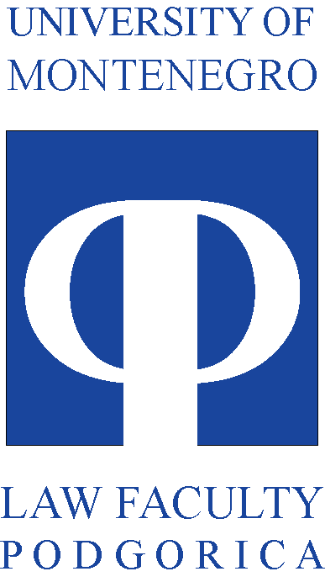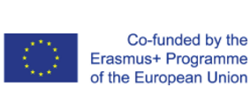

__________________________________________________________________________________

MONTHLY ACTIVITIES REPORT
-JUNE 2019-

Since the Management board is focused on projects progress in terms of expenditure, use of resources, implementation of activities and the delivery of results, in order to assure achievement of the defined goals of the project, one of its functions is to systematically collect and analyze relevant information about project progress. In that regard, Project management team is submitting this monthly report for the May 2019.
From the period from June 1st to June 30th, the entire project team has been employed on tasks relevant for the realization of the CABUFAL activities planned for the summer semester of 2019.
One of the main activities of the project coordinator and the project management team were focused on the preparation of the materials for the upcoming Management board set for the 6th of June at Regents University in London. During the first few days the documents needed for this meeting were finalized.
Since the public procurement calls for the last procurements were not yet realized, the management team was conducting talks about speeding up the public procurement calls procedures for the realization of the public procurement of scientific literature databases, and procurement of books.
Since the project has envisaged study visits to project partners, last of the trips were organized, to Faculty of law Iustinianus Primus in Skopje, and to Faculty of Law University of Ljubljana, in order to give the teaching staff of the Faculty of law University of Montenegro an opportunity to shadow the exams that were conducted by the professors of the partner Universities at the time of the visits.
The two visits were planned for the end of the month, so the project management team was involved in creation of the agendas for these visits, communication with consortium partners, and preparation of the traveling arrangements for the staff attending these meetings.
Since, Faculty of law University of Montenegro, is publishing public call for the enrollment of the new generation of students in June, this opportunity was used to promote the CABUFAL project and further disseminate the results to the new generation of students, that came to apply for the admission at the Faculty of law.

