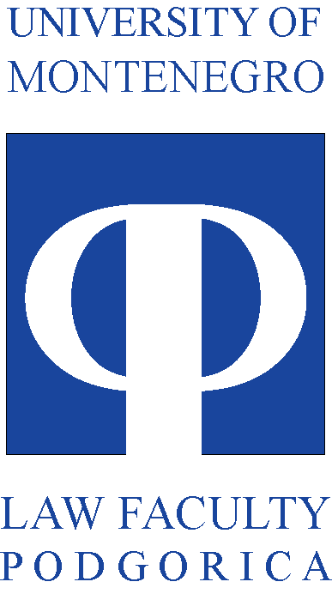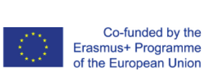

__________________________________________________________________________________

MONTHLY ACTIVITIES REPORT
-APRIL 2019-

Since the Management board is focused on projects progress in terms of expenditure, use of resources, implementation of activities and the delivery of results, in order to assure achievement of the defined goals of the project, one of its functions is to systematically collect and analyze relevant information about project progress. In that regard, Project management team is submitting this monthly report for the April 2019.
From the period from April 1st to April 30th, the entire project team has been employed on tasks relevant for the realization of the CABUFAL activities planned for the summer semester of 2019.
At the beginning of April of 2019, the final Study visit of Faculty of law University of Montenegro teachers and non-academic partners to Faculty of law University of Zagreb was realized. Delegation of Faculty of Law University of Montenegro consisted of the professors Vjera Radovic, Biljana Djuricin, Radoje Korac, Liljana Jokic, Gordana Jeknic, Maja Kostic Mandic, Drazen Cerovic and Aneta Spaic, has visited Faculty of Law University of Zagreb in the period of March 31 to April 4, 2019 within CABUFAL Project.
Following activities were dedicated to the preparation of the promotional materials for the dissemination purposes and the realization of the dissemination event OPEN DAYS of the University of Montenegro planned for the April of 2019. On April 18th the dissemination event took place at the University of Montenegro, and over 3.000 high school graduates were attending the event. During this event Faculty of law has promoted the CABUFAL project and has disseminated brochures on project goals and achievements to all attending future students.
One of the main activities of the project coordinator and the project management team were focused on the preparation of the materials for the upcoming refreshment of the Faculty of law University of Montenegro curriculum, by the recommendations received form the consortium partners. During this period the document on the needs for the curriculum development was finalised.

