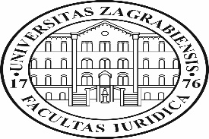
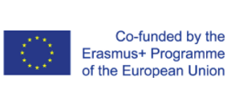
CABUFAL
- MB Meeting in Zagreb -
Capacity Building of teaching staff of the FoL and non-academic partners

Venue | Faculty of Law University of Zagreb  Address: Trg Republike Hrvatske 14
Hotel  recommendations | Hotel Palace ****  Address: Trg Josipa Jurja Strossmayera 10  http://palace.hr/en/  - Situated in the city center, 10-minute walk from Faculty of Law  Hotel Dubrovnik ****  Address: Gajeva 1  https://hotel-dubrovnik.hr/  - Situated in the very heart of the city, on the main square, 5-minute walk from Faculty of Law  Hotel Panorama ****  Address: Trg Krešimira Ćosića 9  http://www.panorama-zagreb.com/homepage  - Situated app. 2 km from the Faculty of Law, public transportation or taxi needed

Agenda
Wednesday, 27 February 2019
 | Arrival of the participants
Thursday, 28 February 2019
 | Breakfast at the hotel
10.00 – 10.30 | Welcome and presentation of the Faculty of Law University of Zagreb  Vice dean Prof. dr Marko Jurić  Assist. Prof. dr Mihovil Skarica
10.30 – 11.00 | Financial aspects of CABUFAL  Dr Nikola Dozic
11.00 – 11.30 | Coffee break
11.30 – 12.00 | CABUFAL overall Performance  Prof. dr Aneta Spaic
12:00 – 13.30 | - Discussion about CABUFAL specific packages.  Best practices in teaching EU law/Publishing…  Refreshment of the curriculum/Faculty of Law proposal for the Senate verification  - Past and future activities  Activities planning in 2019:  MB in London - June 7, 2019  QCB in Podgorica - September 23, 2019
13:30 – 14:00 | Consortium partners positions - financial and other aspects of their CABUFAL positions
14:00 – 14:30 | Tour de Faculty of Law
14:30 – 17:00 | Lunch
Friday, 1 March 2019 | Departure

