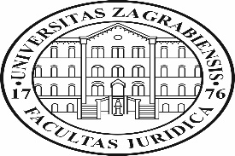
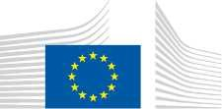
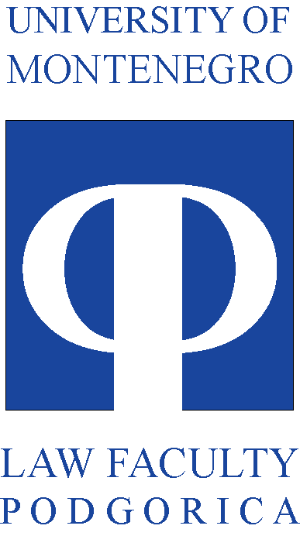

_______________________________
Re: Report on the STUDY VISIT TO Faculty of Law UNIVERSITY OF ZAGREB
Capacity Building of teaching staff of the FoL and non-academic partners

Delegation of Faculty of Law University of Montenegro consisted of the professors Vjera Radovic, Biljana Djuricin, Radoje Korac, Liljana Jokic, Gordana Jeknic, Maja Kostic Mandic, Drazen Cerovic and Aneta Spaic, has visited Faculty of Law University of Zagreb in the period of March 31 to April 4, 2019 within CABUFAL Project. The study visit has been initiated by the welcome speech and presentation of the dean of the Faculty of law – prof. dr Igor Gliha and vice dean prof. dr Marko Juric. The members of delegation have been exposed to the experiences of teaching various disciplines of EU law such as EU Public law, EU Private law, EU Criminal law, Constitutional law, E – learning etc. The lectures have been scheduled within three working days planned for the study visit. More than ten professors have been involved from the side of the Faculty of law and these are: Marko Juric, Mihovil Skarica, Iris Goldner Land, Meliha Carevic, Majda Munivrana Vajda, Alen Uzelac, Ivana Kanceljak, Ana Horvat Vukovic, Zlata Đurđević, Antonija Ivančan, Barbara Preloznjak, Juraj Brozovic etc…

The first day of the study visit has been initiated by the lecture of the prof. dr Iris Goldner Lang. Along with the presentation on the ways of EU law introductory course has became the compulsory subject she provided the information on the current ongoing Jean Monnet Center for excellence which organizes very well established seminars and summer schools established to tackle and delve deep into the various EU topics. It has been followed by the lecture European public law Professor Dr. Melita Carević.

Second day of the study visit has been initiated by the Assistant Professor Dr. Ivana Kanceljak, coordinator for e-learning at the Faculty of Law. She presented on the topic “E-learning system Moodle”. At the same day Professor Dr. Maja Munivrana Vajda has delivered the lecture on the topic “Criminal law in the EU legal system” . It has been followed by the Vice dean Juric report on “Teaching process and modular system of teaching at the Faculty of Law University of Zagreb”.
The practical dimension of study programme (legal clinics, moot courts etc.) has been displayed and further discussed by several leading professor in the field such as: Professor Dr. Alan Uzelac, Professor Dr. Marko Jurić, Professor Dr. Zlata Đurđević and Assistant Antonija Ivančan. Each of them tackled the area od personal and professional expertise.

Third day of the visit, 3 of April has been set for the lectures on the EU law and Constitutional Law taught by professor dr Ana Horvat Vuković. Afterwards, Montenegrin delegation learned from Andrea Horić, Head of the Library about different library connections, electronic scientific data bases and future cooperation possibilities This presentation has been followed by the presentation on international projects, cooperation and courses in foreign languages by Andrea Mišković – Head of the Officer for international cooperation.

The Agenda of the study visit is as follows:
Sunday, 31 March 2019
 | Arrival of the participants
Monday, 1 April 2019
09.30 – 10.15 | Welcome and presentation of the Faculty of Law University of Zagreb  Dean Prof. dr. Igor Gliha  Vice dean Prof. dr Marko Jurić
10.15 – 11.15 | Teaching EU public law – experiences from teachers’ perspective + discussion  Professor Dr. Iris Goldner Lang  Assistant Professor Dr. Melita Carević
11.15 – 12.30 | Lecture European public law
12.30 – 14.00 | E-learning system Moodle: presentation by Assistant Professor Dr. Ivana Kanceljak, coordinator for e-learning at the Faculty of Law
Tuesday, 2 April 2019

10.00 – 11.30 | Criminal law in the EU legal system – Professor Dr. Maja Munivrana Vajda
11.30 – 12.15 | Teaching process and modular system of teaching at the Faculty of Law – Dr. Marko Jurić, vice dean
12.30 – 14.00 | Presentation of the practical dimension of study programme (legal clinics, moot courts etc.)  Professor Dr. Alan Uzelac  Professor Dr. Zlata Đurđević  Professor Dr. Marko Jurić  Assistant Antonija Ivančan
Wednesday, 3 April 2019

10.00 – 11.30 | EU law and Constitutional Law – Professor Dr. Ana Horvat Vuković
11.30 – 12.30 | Presentation of the Library of the Faculty of Law  Dr. Andrea Horić, Head of the Library
12.30 – 14.00 | International cooperation and courses in foreign languages - presentation  Professor Dr. Nina Tepeš – vice dean for international cooperation  Assistant professor Dr. Marko Jurić – vice dean for students  Andrea Mišković – Head of the Officer for international cooperation
Thursday, 4 April 2019 | Departure

